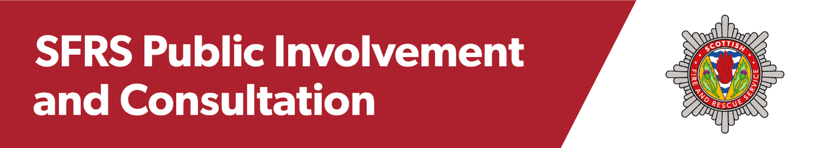

**Public Participation Group**

The Scottish Fire and Rescue Service (SFRS) is looking to establish a Public Participation Group (PPG). The Group will consist of twelve members of the public from across Scotland who will meet up to six times a year to contribute to specific consultation exercises.

The PPG will provide a uniquely **public** perspective on proposals around service development and change. The PPG will:

* Provide a way to capture additional public opinion
* Allow local and regional views to be considered
* Allow SFRS to hear from a more diverse range of people
* Enable the views of the public to be considered alongside service data and specialist opinion.

We are keen to attract people from a broad and diverse spectrum of backgrounds and locations across Scotland. Applications are especially welcome from individuals in under-represented or seldom heard groups.

If you think you might be interested in joining the PPG , please email [SFRS.publicinvolvement@firescotland.gov.uk](mailto:SFRS.publicinvolvement@firescotland.gov.uk) **telling us about yourself, why you would like to be involved and what you could bring to the Group.**

Alternatively, you can write to us at:

**Public Involvement and Consultation Team (PPG)**

**Scottish Fire and Rescue Service**

**Headquarters Building**

**Westburn Drive**

**Cambuslang**

**G72 7NA.**

Please include a contact telephone number.

If you have any questions about the role, please [email](mailto:SFRS.publicinvolvement@firescotland.gov.uk) or call the Public Involvement and Consultation Team on 07879 667801 or 07847096173 for an informal chat.

**Please get in touch by 16 January 2023 to register your interest.**



**Requirements of the Role**

Comprising twelve members of the public, the Public Participation Group (PPG) will support the Scottish Fire and Rescue Service's (SFRS) public involvement and consultation work by providing opinions and insight to ensure that SFRS involves, reflects, and meets the needs of the communities it represents.

**Key Responsibilities**

As a member of the PPG, you will:

* Give your opinion on specific aspects of SFRS policy, service delivery issues, and proposals for change.
* ‘Sense check’ questions for surveys and other communications to ensure they are understandable, relatable and jargon free.
* Consider and discuss consultation proposals.
* Attend up to six meetings per calendar year.

**Practicalities**

* The PPG will work with the SFRS Public Involvement and Consultation Team (PICT).
* Meetings will normally be held online, and so Group members should have adequate digital access.
* There may be occasion for the Group to meet in person, in which case travel expenses will be reimbursed.
* There will be a Group induction and, where practical, that will include members visiting their local fire station.
* If you are unable to fulfil your commitment, or if you no longer wish to be involved in the group, you should provide as much notice as possible.
* No prior or specialist knowledge of SFRS is required.
* Members cannot be an employee of SFRS or be related to anyone who is currently employed by SFRS.
* This is a 2-year pilot project.

**Gratuity**

PPG members will receive an annual gratuity of £150 payable at the end of each year, for attending up to six online meetings.

**What we want in Group Members**

We wish to appoint individuals who are interested in having their views heard, and who enjoy working with other people on a joint piece of work. You should:

* Enjoy working as part of a team.
* Be confident and willing to contribute to group discussions.
* Be comfortable and confident in expressing your opinion.
* Be open to new ideas and approaches.
* Be respectful of different points of view.
* Treat other Group members and SFRS staff, with respect and consideration.
* Show discretion and confidentiality around sensitive or confidential information.

**Essential Skills and Personal Qualities**

Group members should have good interpersonal and communication skills with strong attention to detail. Importantly, we are looking for people with a positive attitude who are reliable, with a willingness to listen and give constructive feedback.